October 2018

Dear Parents and Carers

Southway 50th Anniversary

During the week of the 15th October 2018 we will be celebrating Southway’s 50th Anniversary. The children will have the opportunity, during the week, to immerse themselves in Southway’s history and what life in the 1960s was like for a school child as well as asking the children to look to the future and imagine school life in 50 years time.

Please see below for an outline of the week.

Monday | Children using prime resources to compare school in 1968 and in 2018.  Aerial photograph of the school, children and staff in the shape of 50.
Tuesday | “1968 at Southway” – experience lessons, games and entertainment of the era. If you child has packed lunch, please try and send them in with an authentic 1960s packed lunch.
Wednesday | Children will be doing some work on “The Midnight Gang” by David Walliams in preparation for the Festival Theatre Visit.
Thursday | “2068 at Southway” – what will life be like at Southway in 50 years time?
Friday | 1960s day.  We are inviting the children to dress in 1960s clothing whilst learning about major events around the World in the 1960s.  From 2:45pm – families are invited to visit the school’s museum which will showcase the children’s work from the week in the Main Hall.

The school is looking for memories and photos of Southway from its former pupils and staff. If you came to Southway and have any memories you would like share with the children, please email golden@southwayjunior.co.uk which has been specially set up for this event.

We would also like to create a legacy and therefore are asking families if they would like to donate towards the cost of a book from our ‘100 book challenge’ catalogue. Further details with a list of books will be sent to families in due course. Each book will then be inscribed with the donor’s name.

All the staff at Southway hope that the children will remember this important milestone in the school’s history in years to come.

Yours sincerely
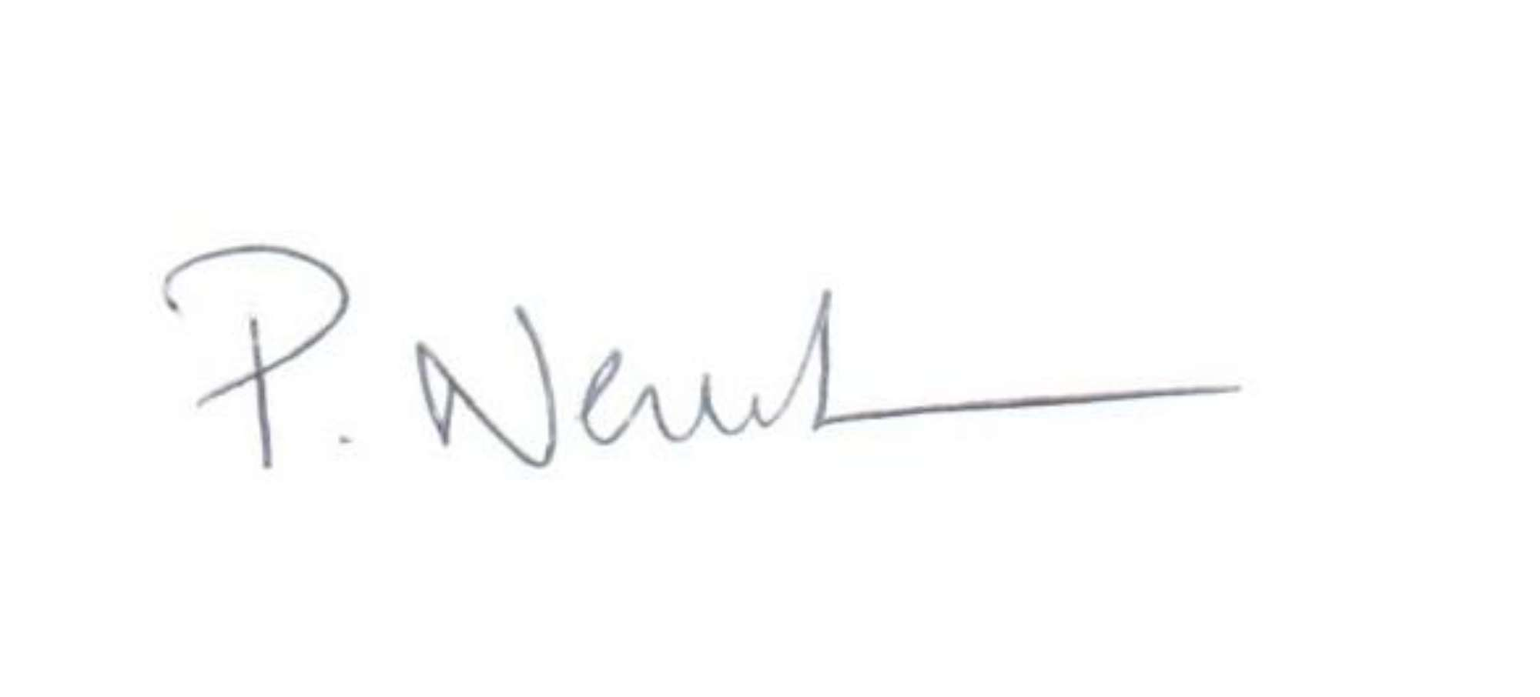
Mr P Newbold
Headteacher

