5th March 2020

Dear Parents & Carers,

Friday April 3rd will be our House Charity Fundraising Day at Southway.
The children may come to school in non-uniform, dressed in the following themes:
Beacon - Pyjamas
Cliff – Sporty
Dyke – Bright/neon
Hill – Wild and wacky
We would appreciate a minimum donation of £1 per child.
Children may also bring in money to spend as other events (each costing 50p -£1.00) are available during the day including a cake sale, second hand toy and book sale, mini sporting events, Guess the Number of Marbles in a Jar and Name the Teddy.
All money collected will be shared equally between our four house charities -
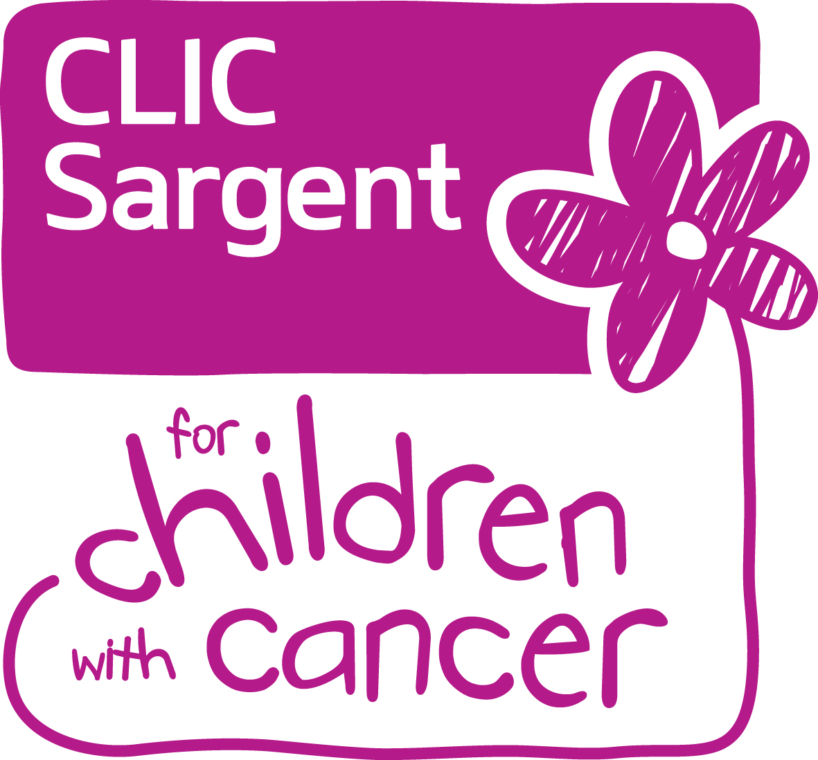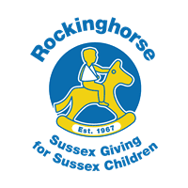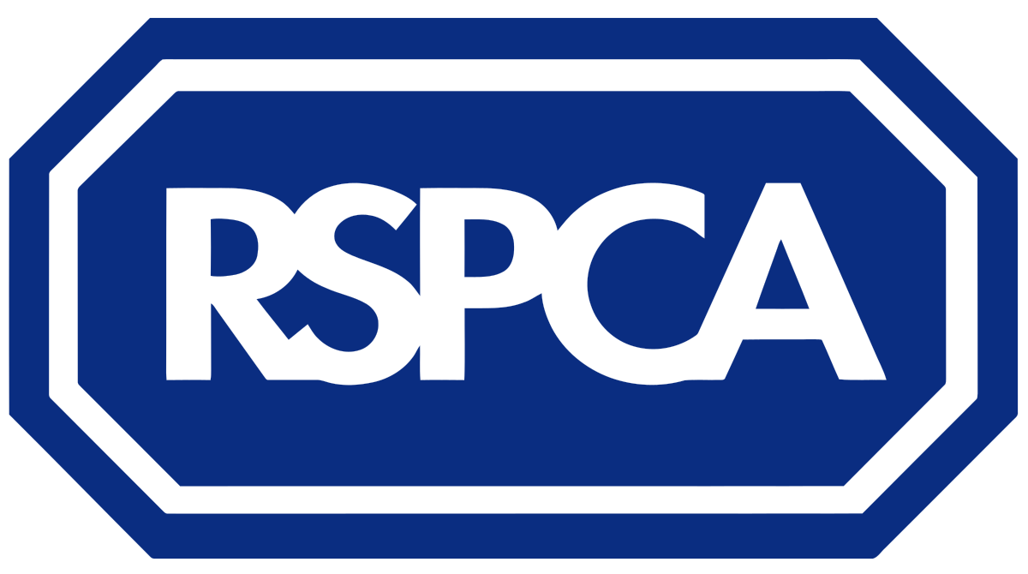
Hill – CLIC Sargent Dyke –Rocking Horse Cliff -Waste Aid Beacon - RSPCA
We would be very grateful for donations of cakes (homemade or shop bought) and children’s toys, games, jigsaws, dressing up clothes and DVDs.
Thank you for your continued support.
Southway Junior School

