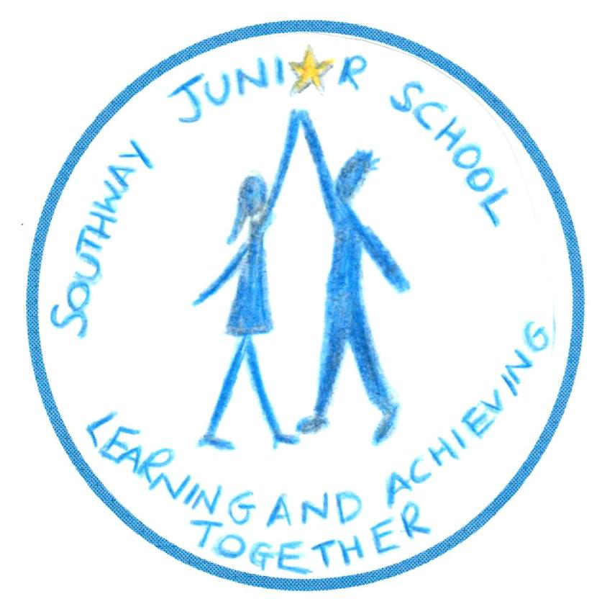

Southway Junior School - Whole School Curriculum Map

Each year group organises the curriculum into three Learning Journeys over the school year. Under an umbrella title, which usually has a Science, History or Geography emphasis, different subjects are woven into the Learning Journey as much as possible in a creative way, to support a broad and balanced curriculum. Children are immersed in their topic, learning the different subject skills and acquiring knowledge and understanding through exciting learning experiences.

Year Group | Autumn Term | Spring Term | Summer Term
Year 3 | Me and My World / Habitats  Geography focus – local area stud  Science focus – Plants, living things in habitats | Invaders  History focus - Pirates, Vikings, Anglo-Saxons  Science focus - Human Body | Battles and Bangs  History focus - Roman Britain, Pompeii  Science focus – Volcanoes, Rocks & Soils
Year 4 | Victorian Towns and Twisted Tales  History focus – Victorian children, Queen Victoria, local area study, rich and poor  Science focus: Electricity and Magnets | Mysterious Mayans  History – The Mayans – society study  Geography – The Americas  Science focus: Light | To Infinity & Beyond  Science focus - Earth and Space,  Solids, Liquids & Gases
Year 5 | Power & Palaces  History focus – Tudors – Henry VIII, Elizabeth I, Court Life, Shakespeare, Town life | Seas, Storms & Survival  Geography focus – Rivers & Coasts, Map Skills, Water Usage  Science – The Water Cycle | Ancient Greece  History focus- Ancient Greece  Geography - European Study
Year 6 | Frozen in Time  Geography focus – atlas skills, world maps, biomes, polar regions | Walk Like an Egyptian  History focus - Egypt / Ancient Civilisations  Geography focus – The River Nile | Blood, Bones and Body Bits  Science focus – Animals including humans – The Human Body

