May 2019

Dear Parents and Carers

No electronic devices / electricity day – Wednesday 12th June 2019

As part of the increased global awareness about climate change, recycling and plastics pollution, we have decided to have a “no electronic devices / electricity” day in school. Children will be taught lessons without the use of the Clevertouch TVs and laptops and weather permitting will spend the majority of their lessons outside in our fantastic grounds, utilising our wide open spaces and designated areas.

The office and admin team will be joining in with this initiative and will only have access to the telephone systems so will not be able to respond to any emails during the day. All electronic communication will be responded to on the following days. If you need to contact the school on that day please call and leave a message if the phones are busy.

We are asking Chartwells to support this as well by not having hot dinners available on that day and asking all families to send their child(ren) in with a packed lunch in a lunch box or insulated bag and NOT a plastic bag. The intention would be for the whole school to have a picnic together. If your child is eligible for Free School Meals we have already ordered them a packed lunch from Chartwells.

We are in discussion with Pioneer Childcare as to how they can adjust their running procedures that day to support this initiative.

Yours sincerely
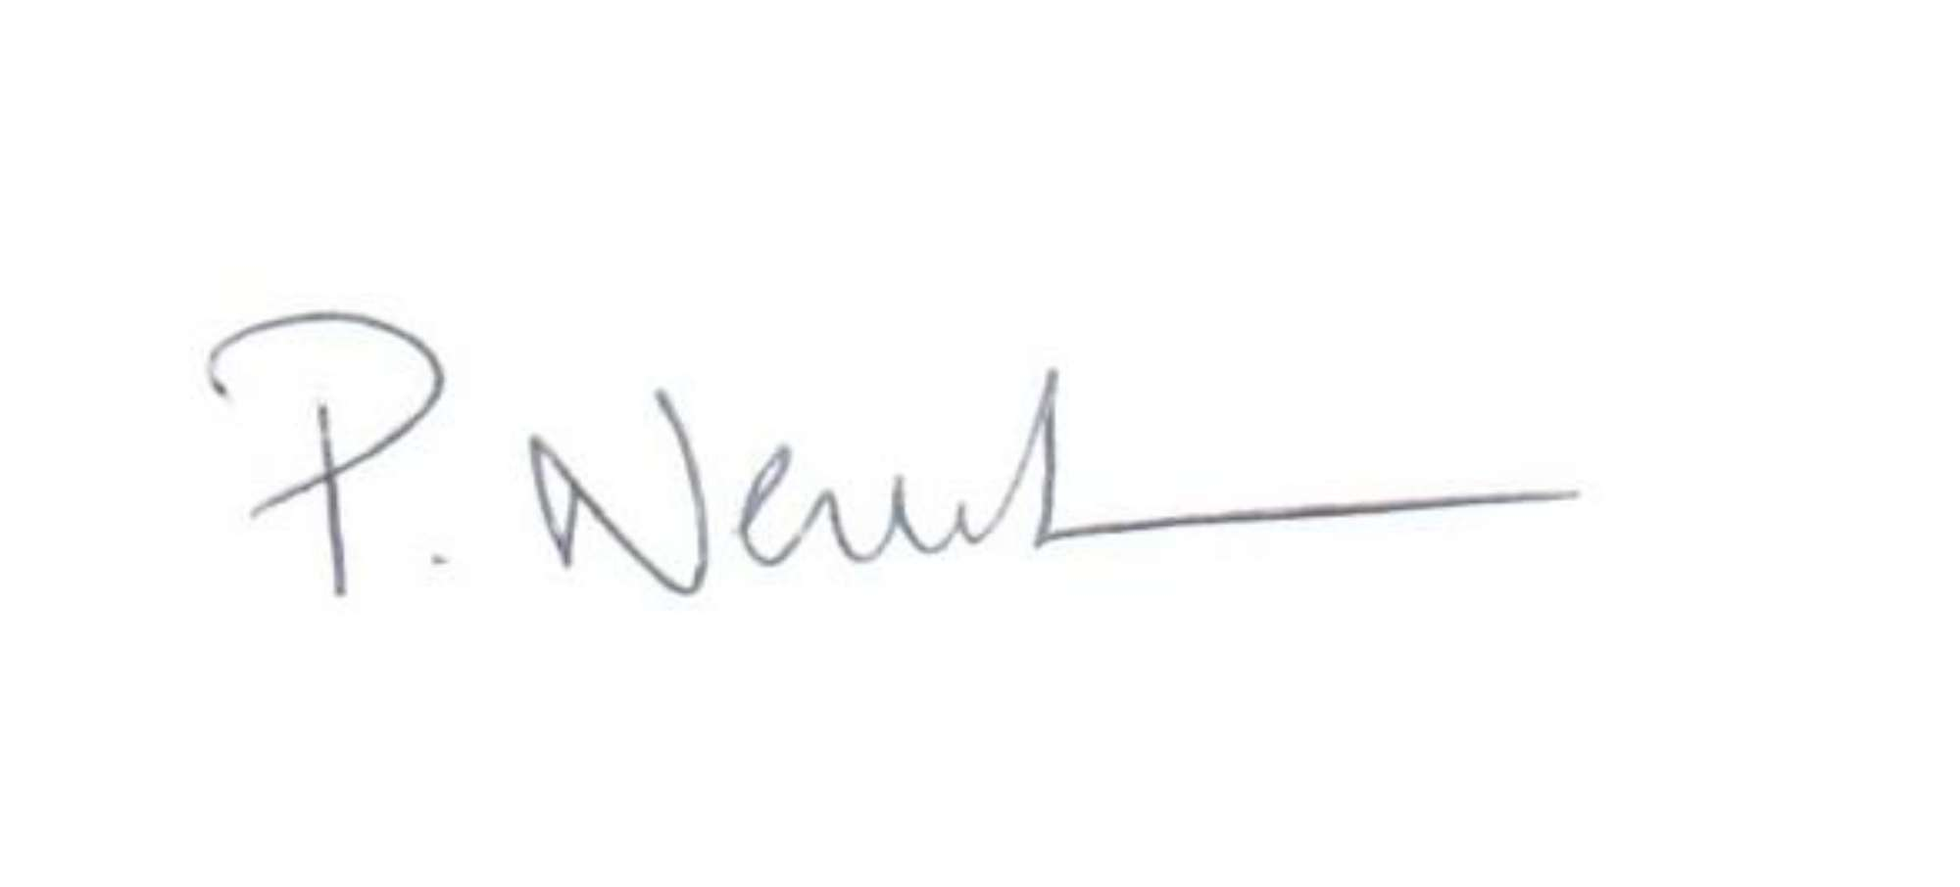
Mr P Newbold
Headteacher

