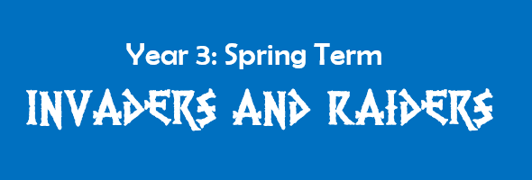



Year 3: Spring Term

**Invaders and Raiders**

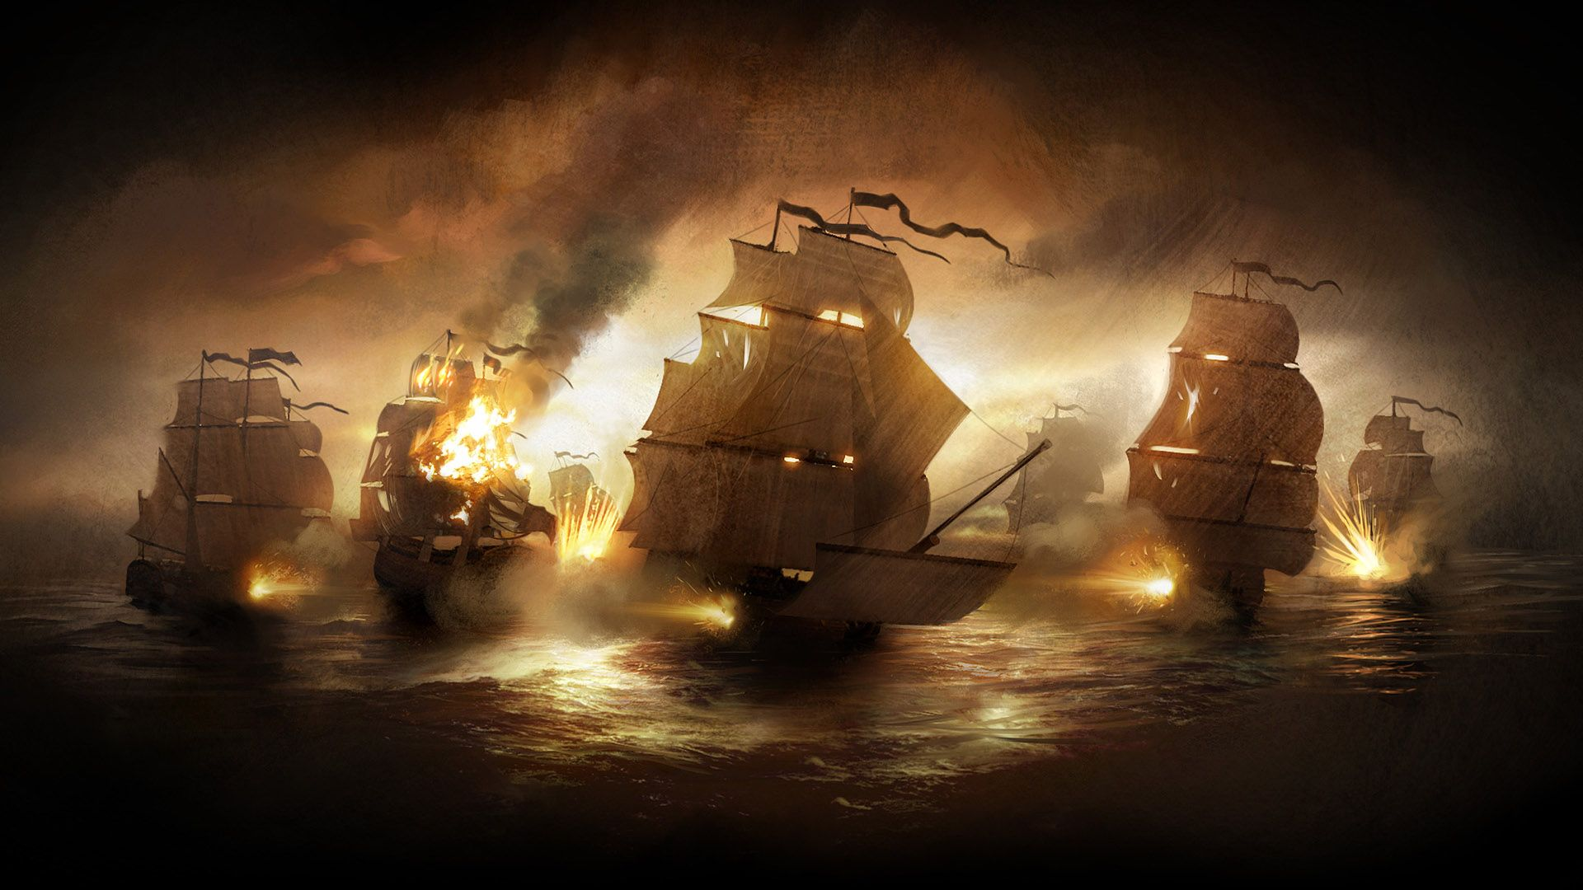

|  |
| --- |
| **Who are the Vikings?**  **Where did they come from and why?**  **What were their battles like?**  **How did they live their lives?**  **How did they travel?**  **Were they all the same?** |

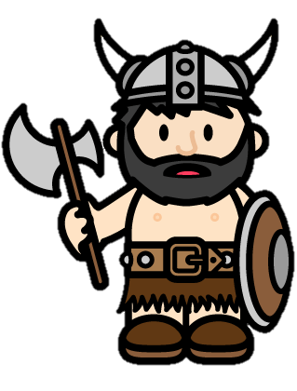

|  |
| --- |
| **Who were the Anglo-Saxons?**  **Why did they raid and invade?**  **Where did the Anglo-Saxons settle?**  **What is the mystery of Sutton Hoo?** |

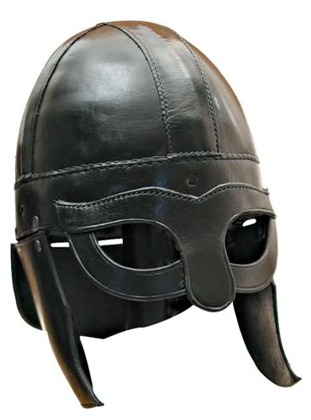

**This term we are going to enrich the**

**learning with…**

**A trip to the Booth Museum**

**A day in the life of a Viking (dress up)**

**A visit from Sir Teachalot**

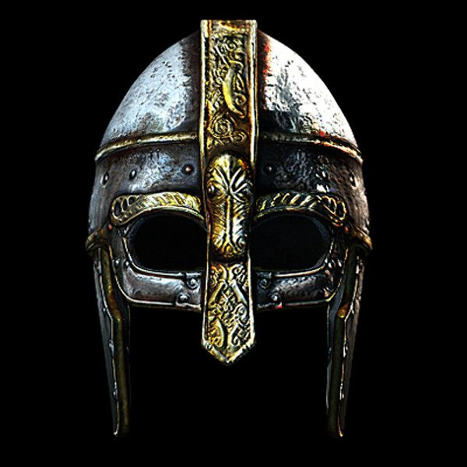

**What will we be doing in each subject?**

Our teaching style at Southway is a **creative, child-centred** one. We aim to develop the children as independent learners and give them opportunities to lead the direction of a learning journey whenever possible. This requires some flexibility within the curriculum but we will cover the following skills over the course of the term.

In English, we will be reading Anglo-Saxon and Viking stories, Viking Sagas and non-fiction books related with Anglo-Saxons, Vikings and the human body. We will be using the story of Beowulf. We will use these to help us to write adventure stories, diary entries and information pages. We will also be reading, writing and performing poems and sea shanties.

We will continue to cover all key strands of the mathematics curriculum in our daily maths lesson.

In science, we will be learning about skeletons, teeth and healthy eating, focussing on the importance of a healthy lifestyle. We will also be looking at how animal and human skeletons differ and why. Our trip to the Booth museum will enrich this curriculum area.

In D&T, we will be examining how and why invaders suffered from scurvy. Using this knowledge, we will create food and drink to solve this terrible problem! We will create a picture frame in woodwork.

We will continue to develop coding skills in Computing, creating our own pirate/Viking ship themed games involving scripts, sprites and algorithms.

We will use music to support learning in other subjects.

PE and games lessons will focus on handball, orienteering and dance

We will be learning about the importance of Easter to Christians in RE. In PSHCE, we will focus on goals, aspirations and emotional wellbeing.

We will continue to develop the children’s knowledge of French through basic conversation skills and introduce vocabulary to describe the human body.



Some of the questions we hope to answer this term are…

* Who were the Anglo-Saxons
* Who were the Vikings?
* What would life have been like for a Saxon or Viking
* How can we make sure we have a healthy diet?
* How can we take care of our teeth?
* How many bones does a human skeleton have?
* Why are animal skeletons different?
* How do our bones help us to move?
* How can we stay healthy?
* What order did key events happen in history?
* What do BC and AD mean?
* What was Sutton Hoo?

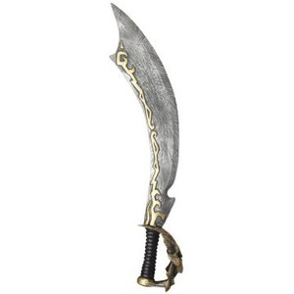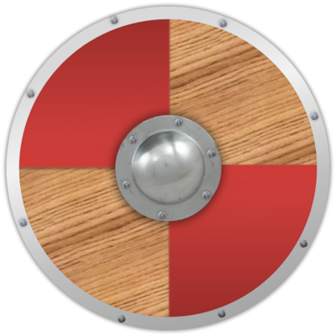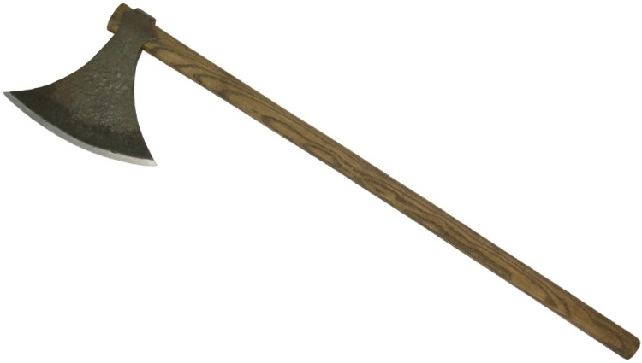



**Help at home by…**

**DOING…**

* **Researching Anglo-Saxon & Viking history**
* **Researching how to keep teeth healthy**
* **Visit the National History Museum**
* **Look at some boats/ships: what are  
  some of their features?**

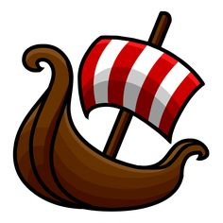



**WEBSITES…**

* **DK Find out: Vikings:**[**http://www.dkfindout.com/uk/history/vikings/**](http://www.dkfindout.com/uk/history/vikings/)
* **BBC class clips**

<https://www.bbc.co.uk/bitesize/topics/zxsbcdm>

**READING (3+ times a week**

* **Information books about Anglo-Saxons and Vikings**
* **Viking Vic – short chapter books**
* **Horrible history books**
* **Beowulf**

