17th November 2021
Dear Parents / Carers

Year 3 – Booth Museum Visit – January 2022

To enrich our learning about the human skeleton in the spring term, we have arranged a visit to The Booth Museum in Brighton. We will attend a one-hour workshop about skeletons to learn why we need a skeleton, how our bones move and how animal skeletons are different. This will be an active session with the opportunity to handle real human and animal bones. There will also be an opportunity for the children to explore the museum after the workshop prior to returning to school. Please read the ‘Briefing Note’ overleaf with further information about the handling of human remains. As the workshop can only accommodate a maximum of 30 pupils, each class will visit the museum and have different session times as outlined below.

Picasso & Dali - Wednesday 12th January – leave school at 08:45 am, arrive back at Southway by 12.30 pm.
Turner – Wednesday 19th January – leave school at 08:45 am, arrive back at Southway by 12:30 pm

Children will be required to wear school uniform including shoes and bring their school water bottle with them. We will return to school for lunch so normal arrangements for lunchtime will be in place.

We recognise that at this time of year families have a lot of financial commitments and therefore we are sending this letter out in advance. You are invited to contribute £17.00 to cover the cost of the entry ticket, workshop, coach and insurance. Payment for this trip can be made on-line or by cash/cheque and the contribution is voluntary. However, we must advise that as the school has extremely limited discretionary funds available, the trip may not take place unless all parents, who are able to, do contribute. If you have any concerns regarding the payment, please contact Mr. Newbold in confidence to discuss whether some suitable arrangements can be made to cover the cost of your child’s participation. If you pay online, please note the consent slip must still be returned to school.

If your child suffers from travel sickness it is important that parents administer the medication prior to arriving at school. If further medication is required for the return journey, teachers may administer on your behalf. Please indicate any travel sickness on the slip below.

Please sign and return the permission slip by Friday 3rd December.

Yours sincerely

Mr A Ridgewell
Year 3 Group Leader
---------------------------------------------------------------------------------------------------------------------------------------------------------
PLEASE COMPLETE AND RETURN TO SCHOOL OFFICE BY FRIDAY 3rd DECEMBER 2021
Y3 VISIT TO THE BOOTH MUSEUM – 12th & 19th January 2022

I agree to my child .............................................................. Class ............................ going on the above visit.

- I am willing to make a voluntary contribution and enclose £17.00 (cheques payable to Southway Junior School).
- I have made an on-line payment.
- I am unable to contribute and will be contacting Mr Newbold.
- My child suffers from travel sickness and will require travel sickness medication.

Signed ......................................................................................... (Parent/Carer) Date ………………………

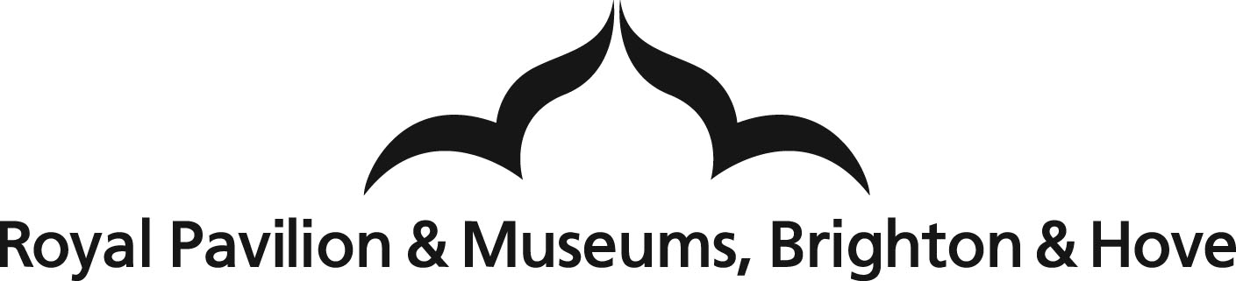
Human Remains Briefing Note

The Royal Pavilion & Museums (Brighton & Hove) has a policy for the care and treatment of human remains in its collections. This is in line with the Department of Culture, Media & Sport’s (DCMS) Guidance for the Care of Human Remains in Museums (2005).

2. What does ‘Human Remains’ mean?

2.1 The definition of human remains for the purposes of this Policy follows that given in the DCMS Guidance:

The term human remains is used to mean the bodies, parts of bodies and cremated remains, of once living people from the species Homo sapiens (defined as individuals who fall within the range of anatomical forms known today and in the recent past). This includes osteological material (whole or part skeletons, individual bones or fragments of bone and teeth), soft tissue including organs and skin, embryos and slide preparations of human tissue.

In line with The Human Tissue Act 2004, the definition does not include hair and nails, although it is acknowledged that some cultural communities do give these a sacred importance. Human remains also include any of the above that may have been modified in some way by human skill and/or may be physically bound-up with other non-human materials to form an artefact composed of several materials. Another, but much smaller, category of material included within this definition is that of artworks composed of human bodily fluids and soft tissue.
(Taken from DCMS Guidance, p9)

2.2 Where it is known that cultural communities give hair and nails sacred importance, this material will be treated in the same way as human remains according to the above definition and as outlined below.

Teaching and learning
8.7 Provided due regard is given to sensitivities and the care of the objects, it is acknowledged that human remains in teaching sessions can have far more educational impact than using models or other media.

8.8 Any members of the public, including teachers, schoolchildren and students, need to be forewarned of any human remains in a museum-based or off-site teaching session. Prior to access to human remains, participants in the session will be told what is meant by dignified and respectful treatment of human remains.

Policy for the Care and Treatment of Human Remains 2009
Royal Pavilion & Museums

