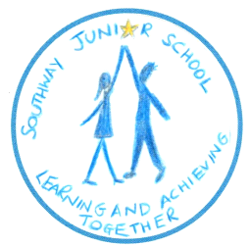
Timetable of Important Dates – September 2019
Transferring from The Gattons Infant School to Southway Junior School

Tuesday 16th April 2019 | West Sussex County Council advise Parents of Admission to Southway | As soon as Southway receive notification, letters to be sent to individual parents/children (week commencing 22nd April 2019).
w/c 6th May 2019 | Welcome Pack & Admission Forms | In order to prepare for your child’s admission we will provide a comprehensive welcome pack with forms for completion.
Friday 24th May 2019 | Admission Forms to be completed & returned | Completed paperwork to be returned to either The Gattons or Southway Junior School Office.
Friday 21st June 2019 | HSA Summer Fayre | Please join us for our annual Summer Fayre.
Wednesday 3rd July 2019  (8.35am-1.00pm) | Year 2 Induction Morning | Year 2 children will spend the morning in their classes at Southway. They will have lunch at Southway and then be collected by Gattons staff to return to The Gattons for the afternoon.
Wednesday 3rd July 2019  (9.15am-10.00am) | Headteacher presentation  (Tea & coffee served from 8.45am in Dining Hall) | Whilst your child visits their Year 3 class, you will be invited to a presentation with the Headteacher, plus an opportunity to visit your child’s class & meet the teacher.
Wednesday 3rd July 2019  (5.00pm) | Headteacher presentation | For those parents unable to attend on the morning of 3rd July, this will be an opportunity to hear from the Headteacher and other key personnel.
Monday 2nd September 2019 | INSET Day | School closed to pupils.
Tuesday 3rd September 2019 | School Opens | Pupils arrive at 8.35am. Registration commences at 8.45am. Parents to take their child to the small playground where they will be met by Year 3 class teachers.
Week 2 of Autumn Term  (Date to be confirmed) | Curriculum & Meet the Teacher Meeting | Parents will be invited to the school for a curriculum meeting with teachers.
Monday 4th November 2019 | INSET Day | School closed to pupils.
November 2019 | Parent Consultations | Your opportunity to meet with your child’s teacher.

