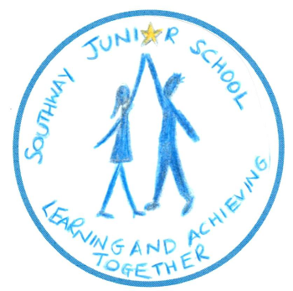
Southway Junior School
Southway
Burgess Hill
West Sussex
RH15 9SU Tel. 01444 233824
email: parentline@southwayjunior.co.uk
Headteacher: Mr P Newbold website: www.southwayjunior.co.uk
_______________________________________________________________________________________________________________________________________

SOUTHWAY JUNIOR SCHOOL

PROSPECTUS

2018 - 2019
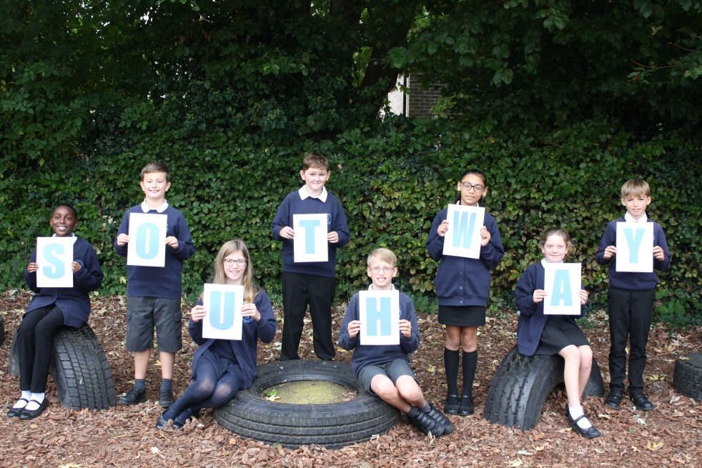

Learning and achieving together
Welcome

Dear Parents and Carers

Welcome to Southway Junior School and thank you for your interest in our school.

Southway is a warm, vibrant school with happy children who love to learn. We have beautiful, spacious grounds, including a large field, several wildlife areas, two ponds, two playgrounds and a small swimming pool.

Our dedicated team of staff work closely together and with you to make the children’s time at school successful, happy and safe. We believe that our relationship with parents/carers is especially important, because with the combined efforts of staff, parent and child, we can reflect our motto ’Learning and Achieving Together.’

I hope this prospectus gives a brief glimpse of school life at Southway, but would urge you, if possible, to come and take a look for yourself. We are always happy to show prospective children and their parents/carers around, both during our open-mornings or individually by appointment. Please contact the office for further details.

I look forward to meeting you.

Best wishes
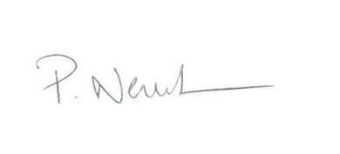
Pete Newbold
Headteacher 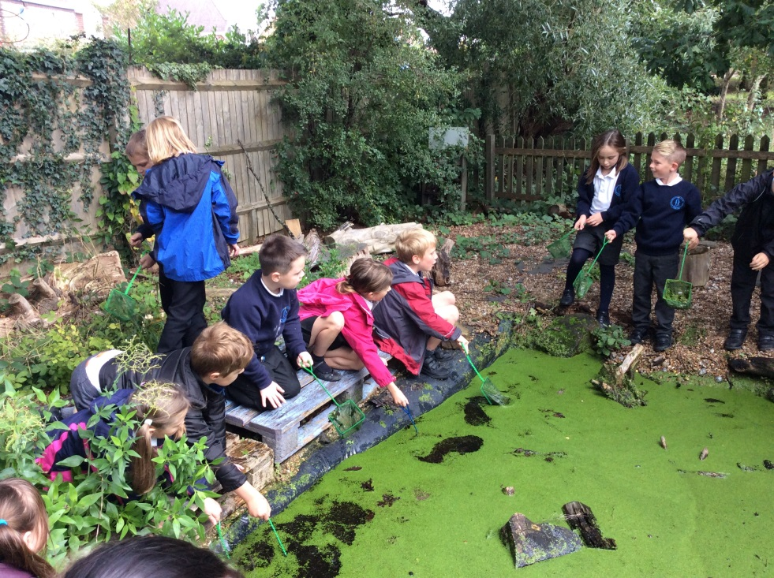

Southway Junior School Vision and Aims.

We want all our children to become happy, confident individuals, who respect others and the world in which they live, achieve personal success and develop an enthusiasm and thirst for learning.

Aims
We aim to provide a learning environment which is child-centred, creative and challenging, so that our children are happy, engaged, work hard and are enthusiastic learners.

We think of the school as a community of learners and recognise the importance of developing individuals’ sense of self-worth and self-respect, as well as respect for others, to help them succeed and achieve. We have high expectations throughout the school and aim to foster children’s independence as they develop their different skills and have fun whilst learning.

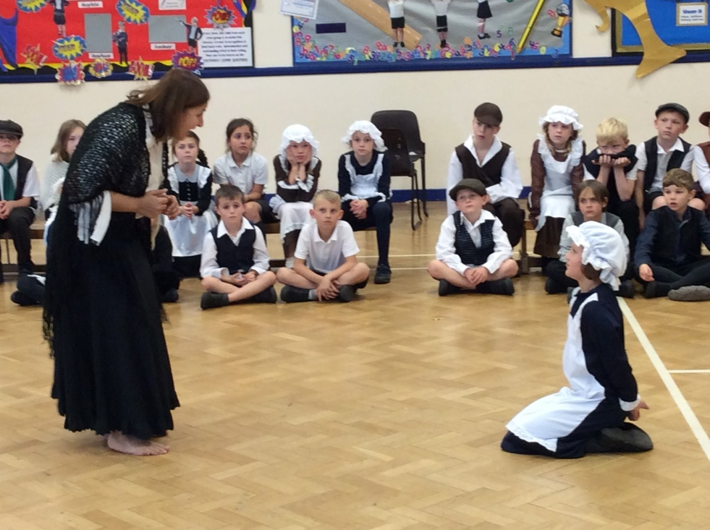
The School
At Southway Junior School we have children in single-aged classes from Years 3 to 6. Our published admissions number is 90 and there are three classes in each year group. The number of children in a class is usually around 26, but ranges from 25 to 30. The vast majority of children transfer to us from The Gattons Infants School and we try to keep them in their same classes in Year 3 to smooth their transition from Key Stage 1 to Key Stage 2.

Our teaching team includes 13 Teaching Assistants who support children in class in the mornings. Each week, when class teachers have their statutory planning, preparation and assessment (PPA) time out of class, the children are taught by the same HLTA (Higher Level Teaching Assistant) to ensure good continuity of teaching and learning.

School facilities include:

- A Sensory Garden
- A Storytelling Garden
- iPads for pupils
- Wireless access to the internet across the school
- Interactive whiteboards or CleverTouch TVs in every class
- Separate dining hall, also used for PE and drama
- An adventure playground and tyre parks
- A bird hide and boardwalk
- Two ponds
- A market garden area with fruit trees and raised vegetable beds
- A cookery and Art / DT classroom
- A hall with staging and lights
- A swimming pool
- A dedicated Learning Resource Centre
- Large fields

Year Group | Autumn Term | Spring Term | Summer Term
Year 3 | Me and My World / Habitats  Geography focus – local area stud  Science focus – Plants, living things in habitats | Scoundrels at Sea  History focus – Pirates, Vikings, Anglo-Saxons  Science focus – Human Body | Battles and Bangs  History focus – Roman Britain, Pompeii  Science focus – Volcanoes, Rocks & Soils
Year 4 | Victorian Towns and Twisted Tales  History focus – Victorian children, Queen Victoria, local area study, rich and poor | Mysterious Maya  History – The Mayans – society study  Geography – The Americas | To Infinity & Beyond  Science focus - Earth and Space,  Solids, Liquids & Gases
Year 5 | Power & Palaces  History focus – Tudors – Henry VIII, Elizabeth I, Court Life, Shakespeare, Town life | We’ll Meet Again  History- World War II  Geography – countries of Europe  Science – properties & changes of materials | Seas, Storms & Survival  Geography focus – Rivers & Coasts, Map Skills, Water Usage  Science – The Water Cycle
Year 6 | Frozen in Time  Geography focus – atlas skills, world maps, biomes, polar regions | Walk Like an Egyptian  History focus – Egypt / Ancient Civilisations  Geography focus – The River Nile | Blood, Bones and Body Bits  Science focus – Animals including humans – The Human Body

Learning at Southway

As a junior school we educate children from ages 7 to 11, covering Key Stage 2. The National Curriculum subjects are taught as much as possible through Learning Journeys.

Learning Journeys
Each year group organises the curriculum into three Learning Journeys over the school year. Under an umbrella title, which usually has a Science, History or Geography emphasis, different subjects are woven into the Learning Journey as much as possible in a more creative, holistic way, to support a broad and balanced curriculum. Children are immersed in their topic, learning the different subject kills and acquiring knowledge and understanding, through exciting, interesting learning experiences.

Educational Trips and Visits
Teachers work hard to find ways in which to enrich the children’s learning with a variety of educational trips and visits. These can include visits to The British Museum, Hampton Court and Preston Park Manor. Our Year 6 residential visit is to Pre Catelan, France.

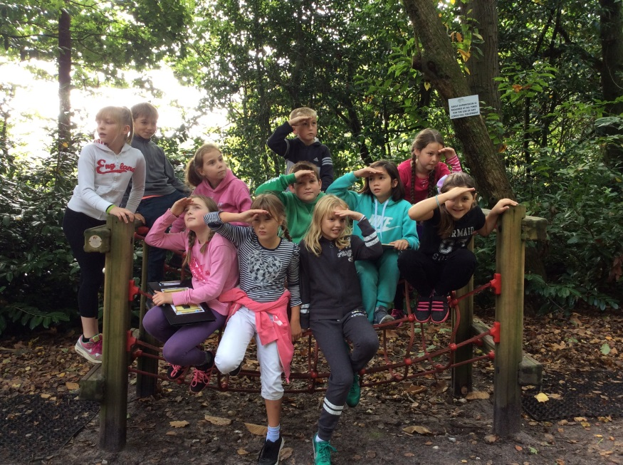
In addition, children learn about religious faiths and beliefs during their Religious Education (RE) lessons, in accordance with the Local Authority’s agreed RE syllabus. These lessons are often but not always linked with their Learning Journey.

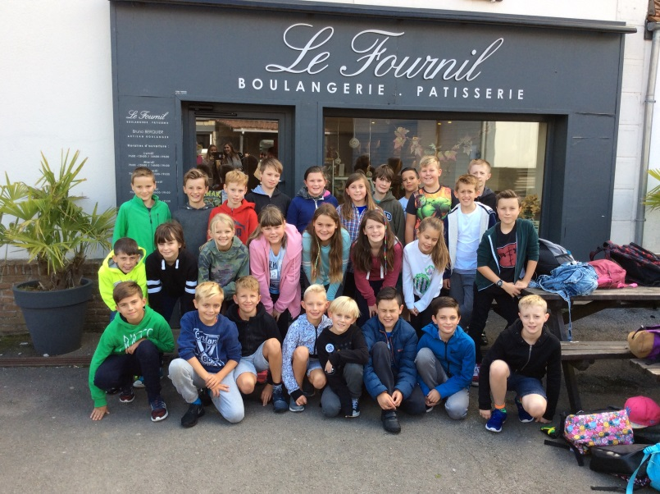

Homework and Take-Away Tasks

Children spend more than 80% of their time at home and we are keen that they have the opportunity to consolidate and extend their learning wherever possible. One of the best things parents/carers can do to help your child at home is to read with them, and we ask that you do this for at least ten minutes, preferably every day.
Each year group sets regular homework tasks each week, and these typically often include learning times tables or mental arithmetic facts or investigating spellings. In addition, take-away tasks are usually set over a period of a few weeks, to encourage children to persevere at a longer-term project, often with family support.

Teachers will also place on our Virtual Learning Environment, ideas for children to extend their learning. Our VLE is moderated by teachers on a regular basis, and all classes are taught how to access it and use it appropriately.

Homework expectations are outlined by Year Group Leaders in their curriculum letters at the beginning of each academic year.

Inclusion

In ‘Learning and Achieving Together’ we aim to support the children so that everyone can succeed at their own level. Within class, lessons are differentiated to cater for children of differing abilities. Our Special Educational Needs Co-ordinator (SENDCo) liaises closely with teachers through the school in order to identify swiftly any concerns and advise on how best to cater for different needs. She also works closely with the SENCo from our infant feeder schools to ensure appropriate provision is made for children who have already been identified as having Special Educational Needs. Once a difficulty is identified, provision is made to meet that need and progress is carefully monitored through an Individual Education Plan (IEP) or, if appropriate, an Education Health Care Plan (EHCP). At later stages the class teacher and SENCo may receive support from outside agencies. Parents/carers are fully consulted and encouraged to take a full part in all stages.

School Captains

Each autumn term, children gather in their houses, Cliff, Dyke, Beacon and Hill , named after local landmarks when the school first opened. Each House has House and Sports Captains from Y6, chosen by all staff. These children are expected to be good role models and responsible members of our school community as well as contribute to any school wide projects. In autumn term Houses compete in a quiz. In spring term Houses raise money for a nominated charity. In summer term Houses compete on the sporting field.

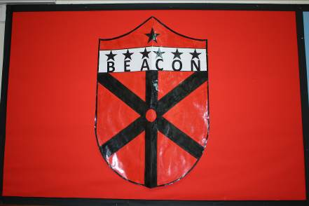
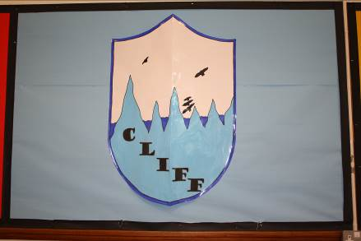
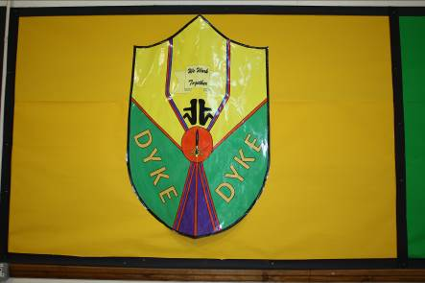
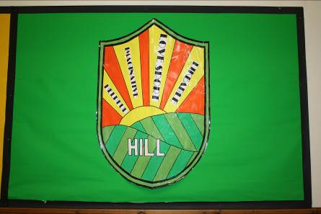
Extra-Curricular Activities
Our four Houses
DYKE, HILL, BEACON and CLIFF

We are really lucky that children have a wide range of clubs and extra-curricular activities to choose from, held either during lunchtimes or at the end of the school day. Clubs are run by members of staff or by outside providers and include gymnastics, coding club, TAG Rugby, drama and creative writing. A full list of clubs is published near the beginning of each term on the school website.
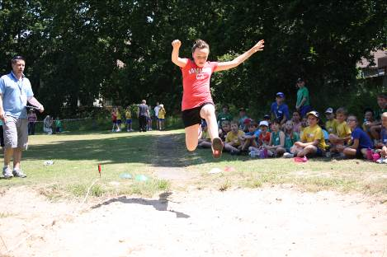
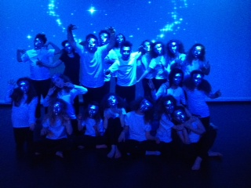

Children as leaders

Children fulfil a variety of leadership roles in the school. These include positions such as House and Sports Captains, Bird Hide monitors, Storytelling Garden monitors and Rights Respecting Councillors.

We encourage all children to act responsibly to sustain the natural environment.

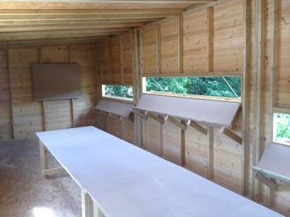
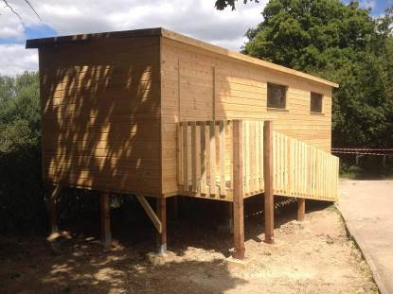

The Southway Day

8:35 – 8:45 School opens & Registration
8:45-10:00 Learning
10:00-10:20 Assembly
10:20–10:45 Break time
10:45–12:15 Learning
12:15 –1:15 Lunch break
1:15 – 3:15 Learning
3:15 End of school day

Children come directly into school from 8:35 to 8:45am, when register is taken. During the first two weeks of the autumn term, the Year 3 children wait with their parents on the small playground, where their teachers will collect them. This provides a safe and gentle transition from Infant school, and once the Y3 children are settled properly into school life, they join the older pupils in coming in via the main school gate.

Assembly is held each morning, Monday to Friday. Assembly is an important part of the school day when we meet together as a community. It is a time when we place emphasis on the development of values and attitudes towards each other and the world around us. Assemblies are non-denominational and although they are of a broadly Christian nature, due consideration is given to the multicultural society in which we live. Friday mornings often feature a class-led assembly, to which parents and carers are warmly welcomed.

Parents have the right to withdraw their children from religious education and collective worship should they so wish. If parents do not wish their child to be taught the agreed syllabus or take part in short acts of collective worship then they should inform us in writing. Their child can then be excused and suitable alternative arrangements made.

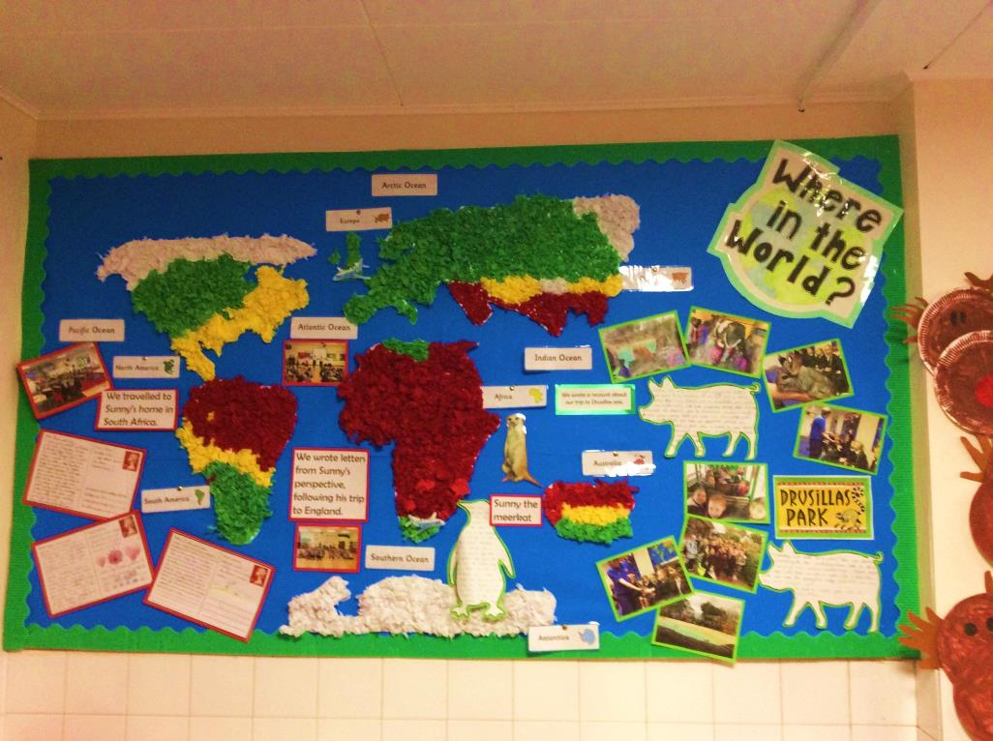
Playtimes

Morning break: 10:20 – 10:45
Lunchtime: 12:15 – 1:15

Playtimes are an important part of the children’s day at school, and an essential opportunity to exercise, develop social skills and learn how best to get along with each other. We are lucky enough to have plenty of outdoor space at Southway and try to use as much of it as possible during playtimes.

We have two playgrounds, - the main one is used by everybody but the small playground at the front of the school is just for Years 3 and 4 to use. Both playgrounds have a tyre park and a range of play equipment for children to use. During the summer months, the children can spread out and play on the field as well. Children love to play amongst the mature trees, often collecting acorns and conkers, but the most popular item is the adventure playground, which is timetabled for different year groups through the week. The tyre parks, climbing wall and adventure playground were bought for the children by the Home School Association, following consultation with the children’s school council.
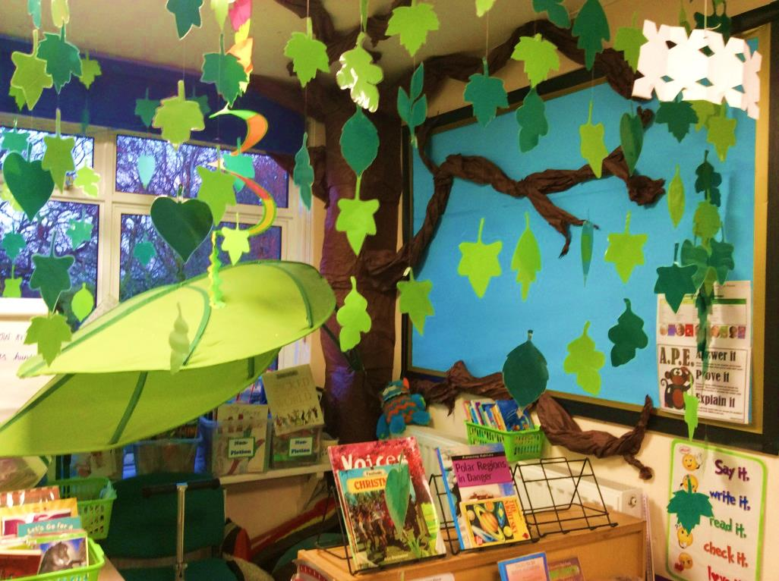
Some children find it difficult to cope with the excitement and stimulation of playtimes, and for them we use a dedicated classroom with more structured indoor games and its own, quieter outdoor area.

Behaviour
Southway Junior School has achieved the Rights Respecting Schools Award (RRSA), Level 1.
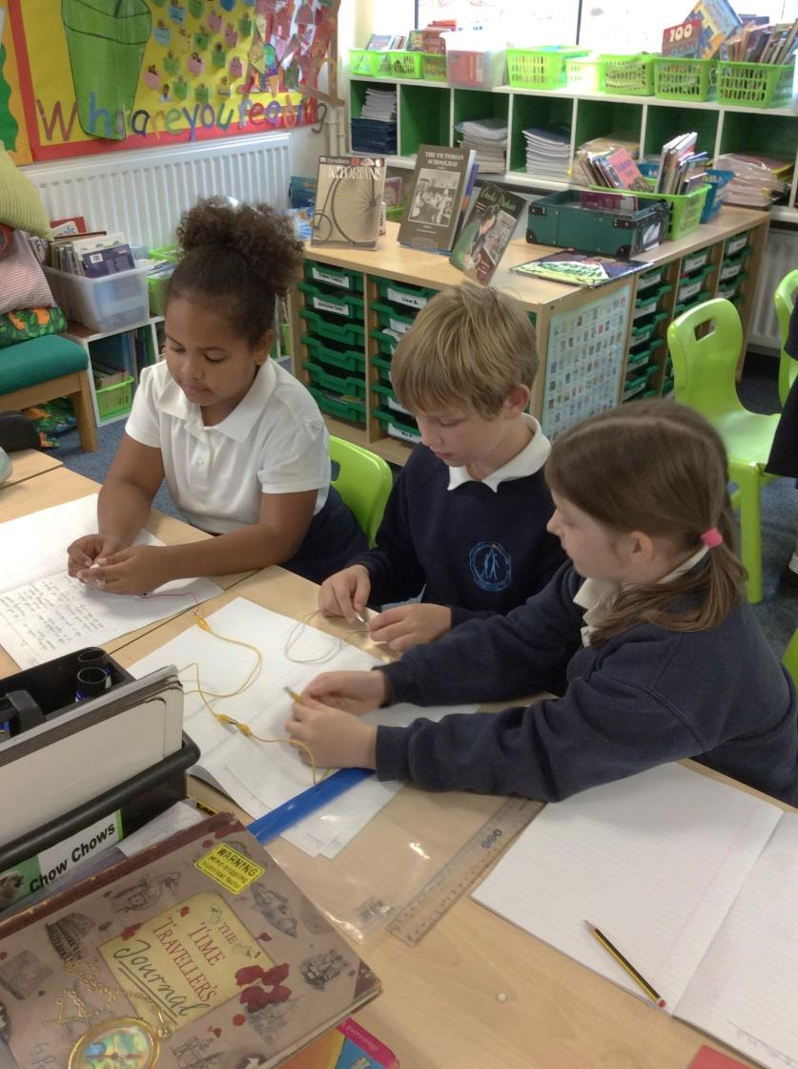
Children behave well at Southway and we expect and encourage them to take responsibility for what they do. Classes agree their class charters rules at the beginning of the year, underpinned by Southway Sun and Stars charter agreed as part of our Rights Respecting Schools ethos:
We have the right to… | We have the responsibility…
Be looked after and kept safe | Looking after ourselves and others
Learn and achieve together | Staying focused , doing our best; challenging ourselves
Be treated equally | Treating others the way we would like to be treated
Relax and play | Playing fairly, showing equal respect
A clean and tidy environment | Looking after our school grounds and equipment carefully
Be heard | By listening to everyone’s views

We believe that children respond best to praise and positive behaviour management techniques, and reward good behaviour in a number of ways. House points are always popular rewards, but so also is our weekly commendation assembly, in which good learning, effort, attitudes or behaviour are recognised and written in the commendation book, standing in the entrance foyer. At the end of each term we hold a special Teachers’ ‘Golden Awards’ assembly, during which children’s efforts over the preceding term are celebrated. Parents/carers of these children are notified in confidence in advance, so they can share their childrens’ successes.
School uniform
Safeguarding

Southway Junior School is committed to ensuring that children are safe and that their well-being is promoted at all times. Safeguarding systems and procedures are in place to ensure that concerns are investigated and appropriate action, usually involving other agencies and services is taken. Parents and carers are encouraged to join with our staff, pupils and governors to ensure that all concerns are passed on confidentially to a senior member of staff. The school has a duty of care and will make referrals to other agencies where necessary.
At Southway we encourage children to wear school uniform to show they are a proud part of our school community.

Boys
White polo-shirt / white shirt
Navy blue sweatshirt with logo
Dark grey/black trousers or shorts
Navy fleece with logo (optional)
Black ‘leather look’ shoes – no boots / canvas shoes
Black/grey/navy/white socks (no logos)

Girls
White polo shirt / white blouse
Navy blue sweatshirt / cardigan with logo
Dark grey/navy/black skirt or school style trousers
Blue & white striped or checked summer dress
Navy fleece with logo (optional)
Black ‘leather look’ shoes – no boots, canvas shoes heels or backless sandals
Black/grey/navy/white socks or tights (no logos)

PE Uniform
House colour t-shirt with school logo
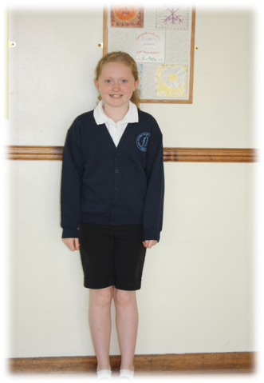
Royal blue shorts
Sweatshirt
Plimsolls or trainers are required for field or
playground games
Track-suit for outdoor PE in cold weather
(preferably navy blue or black)
A cloakroom bag for PE
Football boots are not compulsory but may
be bought if desired

Swimming Kit
Swimming costume
Swimming hat (compulsory for all – can be
purchased from the office)
Towel
All in a named bag (swimming bags can be bought from the office)

As regards the school logo, as long as your child wears the correct school colours we do not insist on having the school logo. However, the items do have to be completely plain and free of any other logo/brand name.
Uniform for sale
School uniform with the logo can be purchased from Sussex, Uniforms, Bridge Road Business Park, Unit 1 & 2, Bridge Rd, Haywards Heath RH16 1TX www.sussexuniforms.co.uk

Jewellery and Hair
Long hair should be tied back. Extreme hairstyles are not permitted. Jewellery should not be worn to school. If your child has pierced ears, small stud ear-rings are allowed, but must be removed or taped up for PE and games. If your child wears a watch to school, s/he must be responsible for it. MedicAlert bracelets are permitted.

Personal Belongings
Although we welcome items of interest that support the class Learning Journey, staff cannot accept responsibility should they get lost or broken. It is far better to leave any personal items at home, especially if they are of value. Children are expected to be responsible for their own personal school equipment, which should be clearly named.
Please ensure that all of your child’s school uniform is clearly NAMED.

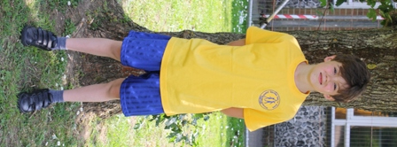
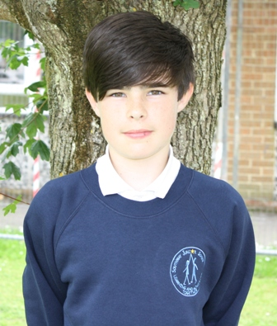
School meals
Tasty, nutritious hot meals are provided by Chartwells and can be ordered online in advance https://westsussex.mealselector.co.uk//: or you can phone them on 0845 603 7998. Meals cost £2.30 per day. Families in receipt of certain benefits (eg Income support) are entitled to free school meals – please ask for a form from the school office.

Children may bring in a packed lunch, which they eat with their year group in the dining hall. In keeping with our Healthy School ethos, we ask that you provide a healthy lunch and suggest that it includes at least one item of fruit or vegetable and no more than one ‘treat’ (eg chocolate bar or packet of crisps). Fizzy drinks, cans or glass bottles are not allowed in school.

Break time snack
Children can bring in a healthy fruit or vegetable snack for morning break time to keep them going until lunchtime.

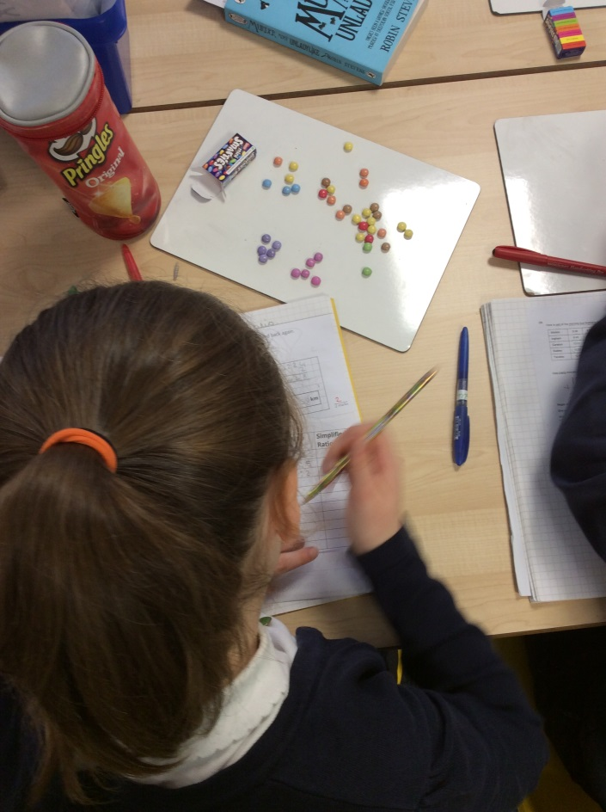
Water
Every classroom has tap water available, and we recommend that children keep their own, named water bottle in class so they can stay properly hydrated throughout the day. Water bottles are available from the school office, price £1.20.

Partnership with Parents, Carers and the Local Community
At Southway we value the relationships school has with parents and carers. The school has an ‘open-door’ policy to encourage parents/carers to alert the school of any issues which may be affecting a child, or to pop in should you wish to discuss something. Teachers escort their classes to the playground at the end of each day, and this is often a useful, informal opportunity to share good news or iron out any concerns.

We build in various events to keep parents/carers involved in and informed about school life. These include:
- Parent consultation evenings in autumn & spring terms – an opportunity to discuss your child’s progress and learning with their class teacher.
- Interim Reports in the autumn term prior to consultation evenings
- Annual school reports in the summer term – a written summary of your child’s progress over the year and suggested targets for the following term.
- Fortnightly newsletter with key dates, events, reminders, school and community information.
- ‘Meet the new teacher’ sessions at the end of the summer term, and at the beginning of the autumn term, when the year group’s curriculum and routines are explained.
- Curriculum workshops organised on an ad hoc basis to help parents/carers support their children at home. In the past we have run literacy, maths and ICT sessions, including internet safety and how we teach calculations.
- Curriculum leaflets – these are sent home at the end of each term, outlining the next term’s learning journey. They include helpful websites and suggestions of how you might enrich your child’s learning.
- Open Afternoons where parents and carers are invited in to spend time in classrooms with the children and share work.

Home School Association (HSA)
All parents/carers are automatically members of the HSA when they join the school community. We are very lucky to have a really committed and dynamic committee which leads the fund-raising for school and runs social events for families and children. As well as the much-loved Christmas and Summer Fairs, the HSA holds termly children’s discos and other events such as the family bingo evening and adult quiz night. Thanks to their fund-raising, children at playtimes can now practise their balancing on the tyre parks and exercise their upper body strength on the adventure playground, and access our large wildlife pond.

Governing Body
The Governing Body is a mixture of Local Authority, Parent, Community and Staff Governors, who bring to the school a broad range of skills, interests and experience. The full Governing Body sits once a term and the committees usually meet each month. Minutes of the Full Governing Body meetings are published on our website.

Induction and Transition
We have very close links with The Gattons, our feeder Infants school, and staff from Years 2 and 3 work closely together throughout the year to ensure a smooth transition. During the summer term, children from Year 2 have various opportunities to work with teachers and Year 3 at Southway, so that they know the routines and are acclimatised to their new school. Parents and Carers are also invited to an induction meeting in the summer term on one of these transition mornings, so that they can see their children in what will be their new classroom.

In Year 6, all children have a day in the summer term when they will attend their new secondary school. Year 6 teachers liaise closely with the Year 7 team to ensure as smooth a hand-over as possible. Our SENDCo also arranges extra visits where appropriate for some children. In addition, children in Years 5 and 6 will often have opportunities to attend enrichment courses at local secondary schools.

Results
Shown below are the end of Key Stage 2 results for the 2018 year six cohort. More detailed information can be found on the following website: https://www.compare-school-performance.service.gov.uk/school/125941
They are made up of test results for reading, maths and GPS (grammar, punctuation and spelling) and teacher assessments for writing and science. RWM is a combined measure of reading, writing and maths. Figures indicate the percentage reaching age expectations.

School | Reading | Writing | Maths | GPS | RWM
Southway | 76% | 78% | 83% | 88% | 69%
National | 75% | 78% | 76% | 76% | 64%
West Sussex | 76% | 75% | 73% | 75% | 55%

Come and see us!
We hope that this prospectus has given you a flavour of what Southway is all about, but nothing can compare with visiting the school in person. For details of prospective new parents meetings, or to make an appointment, please contact the school office on 01444 233824.

We look forward to meeting you.

Contact Details
Southway Junior School
Southway
Burgess Hill
West Sussex
RH15 9SU

Tel: 01444 233824
Email parentline@southwayjunior.co.uk
Website http://www.southwayjunior.co.uk

Headteacher: Mr Pete Newbold
Chair of Governors: Mr Peter Izard

