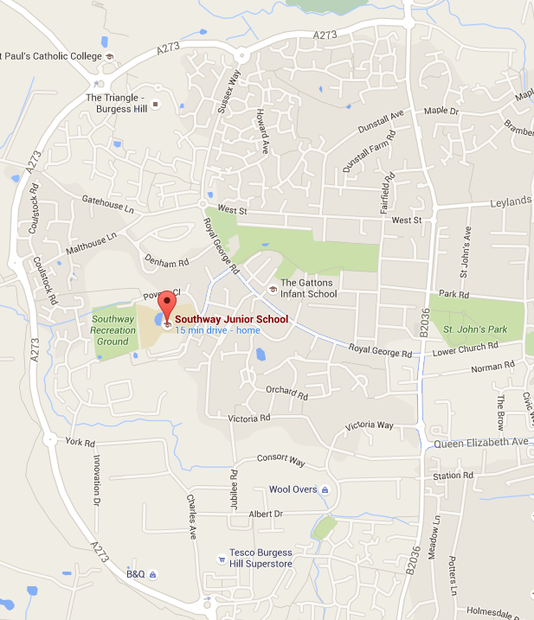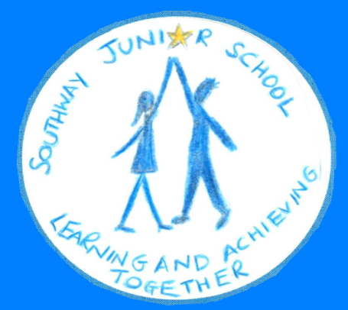

**Help at home by…**

Year 3 Autumn Term

**Me and My World!**

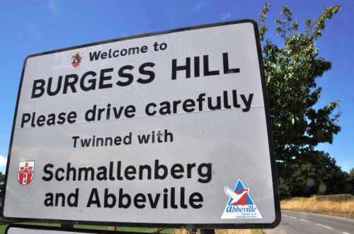

**DOING…**

* Researching countries around the world
* Growing plants from seeds
* Exploring Burgess Hill
* Going on a bug hunt
* Collecting leaflets about the local area
* Looking at and reading maps

|  |
| --- |
| **Where do I live?**  **How can I find Burgess Hill on a map?**  **What countries make up the United Kingdom?**  **What can I do in the local area?**  **How do people get about?**  **What physical characteristics does my area have?**  **What are geographical similarities and differences in other regions?** |

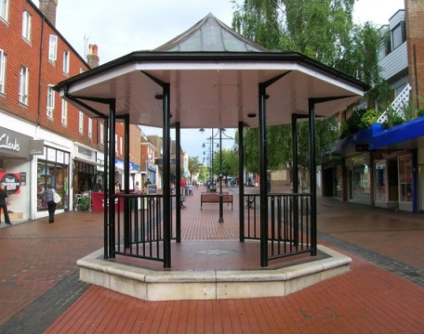

**READING…**

* Information books about habitats, animals, and plants.
* The Vanishing Rainforest by Richard Platt
* Miranda the Explorer by James Matthew

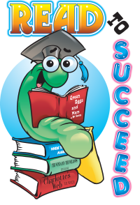

**What are habitats?**

**Why do animals choose their habitats?**

**How can we classify different living things?**

**What habitats are beyond my local area?**

**Why is it important to protect habitats?**



|  |
| --- |
|  |

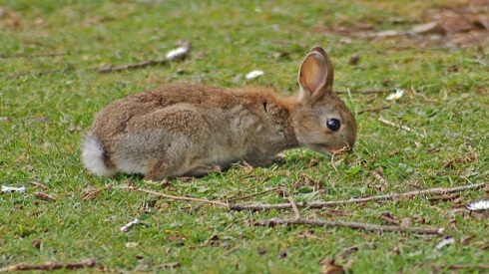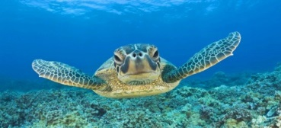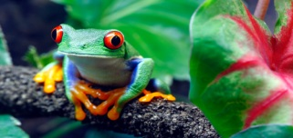

**WEBSITES…**

* Ordinance survey ‘mapzone’ for children:  
  <https://www.ordnancesurvey.co.uk/mapzone/>
* Kids Mongabay: <http://kids.mongabay.com/>
* Sky ‘enimals’: <http://www.skyenimals.com/browse_habitat.cgi>

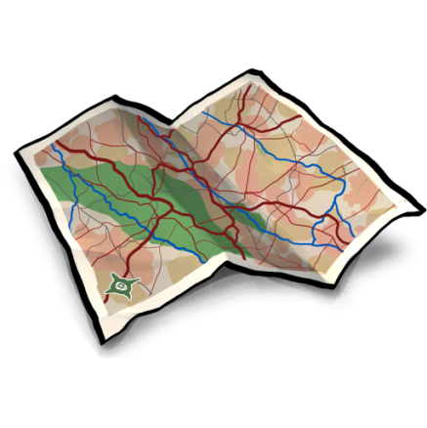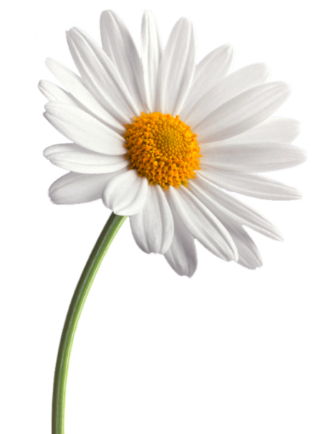

**What will we be doing in each subject?**

**Our teaching style at Southway is very a creative, child-centred one. We aim to develop the children as independent learners and give them opportunities to lead the direction of a learning journey whenever possible. This requires some flexibility within the curriculum but we will cover the following skills over the course of the autumn term.**

In **English** we will learn how to persuade. We will also write instructions, letters, write stories and create and perform poetry.

In **mathematics** we will start by looking at place value and then use this knowledge when looking at formal methods to solve problems involving the 4 operations.

In **science** we will be learning about and growing plants and investigating animals’ habitats and how to classify these animals.

In **PSHCE**, we will be focusing on new beginnings to secure a smooth transition and allow children to happily settle into Southway. Throughout the term extra cross-curricular lessons will provide context and purpose to ensure all children have a strong start.

In **computing** we will learn about internet safety before introducing the children to the VLE (home learning) as well as using the internet for research and using databases to organise information.

**PE** lessons will cover movement and shape in gymnastics as well as invasion games including football.

**Art** and **DT** lessons will focus on collage, photography, woodwork and cooking.

In **geography** we will be learning about habitats around the world, developing atlas skills , fieldwork in the local area and the mapping the physical and human features of Burgess Hill. We will also consider the environmental issue of saving animal habitats.

We will learn key words and greetings in **French**.

In **music** we will be composing and performing music to represent animals.

We will enhance our learning with a visit to Drusillas. We will also embellish our curriculum with numerous outdoor learning and local visits.

How are maps created?

How do plants grow? How do they adapt to their environment?

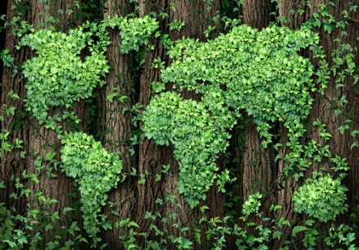

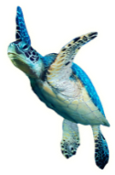

**Some of the questions we hope to answer this term are…**

* What can we do in Burgess Hill?
* How is Burgess Hill the same and different from other areas?
* What habitats are there in our local area? How and   
  why do they change?
* What is the climate like in different habitats?
* What animals live in and around our school grounds?
* How do they affect habitats?
* How do animals adapt to their habitats?
* How do plants grow? Which factors influence their growth?
* How can we help to save different habitats?
* What are the names and locations of countries, cities and counties in the UK?
* How can we recognise environmental changes and what can we do to help?
* How are plants pollinated and how are seeds dispersed?

