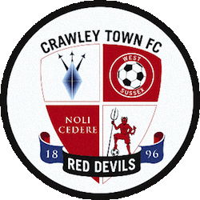
The Peoples Pension Stadium
Winfield Way
Crawley, RH11 9RX
Tel: 01293 410 000
www.crawleytownfc.com
Dear Parents/Guardians

Crawley Town Community Foundation will be delivering a Football After-School Club for all pupils at Southway Junior School.

Crawley Town Community Foundation is the non-profit charitable arm of Crawley Town FC. We aim to provide sporting, recreational and educational activities in order to inspire people above and beyond their vision of capability through the power of sport.

Our coaches are DBS registered; first aid and safeguarding trained; and have a wide range of coaching experience with all ages enabling our sessions to be fun and in a safe setting.

Day: Monday Start Date: 13th January Time: 15:25 – 16:25

End Date: 16th March

The cost of the club is £31.50 for the 9-week block working out as £3.50 per session, or alternatively you can pay for individual sessions at £4 per session. This can be paid via our secure online payment platform OSS.

CRAWLEY TOWN COMMUNITY FOUNDATION | SOUTHWAY JUNIOR SCHOOL

OSS Step-By-Step Guide

STEP 1 – https://officialsoccerschools.co.uk/crawleytown/southway-junior-football-after-school-club-2019-2020-spring-term.html

STEP 2 – Select your sessions/block of sessions

STEP 3 – Fill in Attendee Information and Emergency Contact Details

STEP 4 – Confirm the Contents of your basket

STEP 5 – Enter Payment Details

STEP 6 – Receive Booking Confirmation via email

