19th November 2018
Dear Parents/Carers

Sing-a-long Carol Concert – Thursday 6th December 2018

Children in all the year groups will soon be rehearsing our Sing-a-long Carol Concert. This year we are delighted to be able to hold our perfomances at The King’s Church, Victoria Road, Burgess Hill. The performances will be on Thursday 6th December at 2:15pm and at 6.00 p.m, both lasting approximately 45 minutes. Children may wear a Christmas jumper to the performances.

Please could all parents pick their children up (apart from those going to Pioneer) from The King’s Church at 3.15pm on Thursday 6th December

You are warmly invited to one of the performances and for seating purposes, please complete and return the slip below by Friday 30th November. After this date we cannot accept any further requests.

This year we will have approximately 400 seats available at each performance, however, to be fair to all families 2 seats per child may be requested on a first come first served basis. There will be no entry without a ticket/reserved seat.

Tickets will be sent out on Wednesday 5th December. At the performance we will be supporting our four House charities, NSPCC, RSPCA, Clic Sargent, and Young Minds, so any donations would be most welcome.

We look forward to seeing you on the 6th December.

Yours sincerely

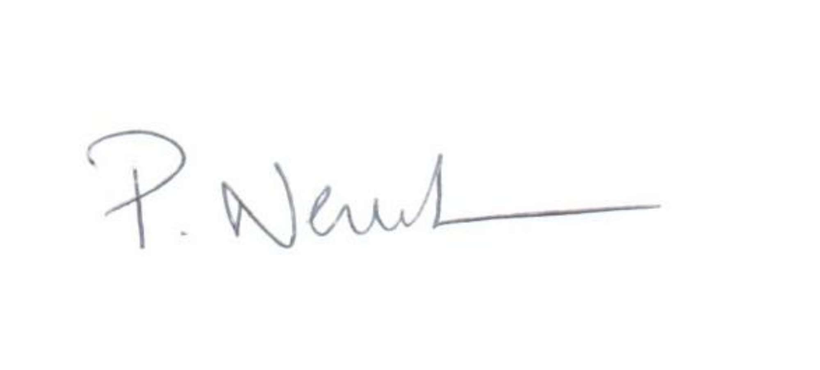

Mr P Newbold
Headteacher
---------------------------------------------------------------------------------------------------------------------------------------------------------
PLEASE COMPLETE AND RETURN BY FRIDAY 30th NOVEMBER
Sing-a-long Carol Concert – Thursday 6th December

Child’s Name ____________________________________ Class _________________________

- I require __________ seat(s) for the 2:15 pm performance on Thursday, 6th December.
- I require __________ seat(s) for the 6.00 pm performance on Thursday, 6th December.
- I will collect my child from The King’s Church at 3.15pm on Thursday 6th December
- My child will be going to Pioneer following the afternoon performance
- My child will be collected after the evening performance at 6.45 pm by…………………………………………………………………………

Signed __________________________________ (Parent/Carer) Date ____________________

